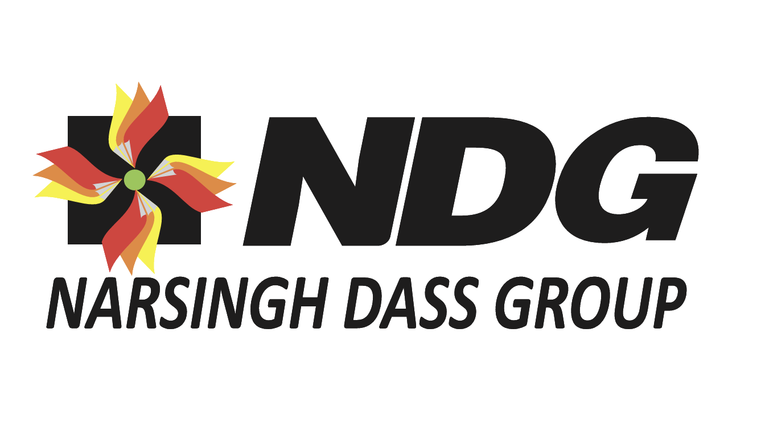
What you’re really looking at
This logo is doing three jobs at once:
- Signalling legacy
- Representing the paper trade
- Quietly asserting scale and reliability
And it does this without shouting.

1. The Symbol: the pinwheel / paper-flower form
At first glance, it looks decorative. It isn’t.
Possible interpretations (and why they matter)
a) Sheets of paper in motion
Each petal resembles a folded or flowing sheet. Together, they form rotation.
What this says:
- Paper doesn’t sit still in your business.
- It moves, circulates, transforms, reaches many hands.
For a trading company, that’s the core truth.
b) Many sources, one center
Different colours, different directions, all anchored to a single green core.
What this says:
- Multiple mills, suppliers, grades, qualities
- One trusted hub that brings it all together
That hub is the Group.

c) Continuity and flow
The circular motion suggests cycles, not transactions.
What this says:
- Long-term relationships, repeat business
- Not deal-making. Dependability
Very 1958 energy, in the best way.

2. The Green Centre
This is a subtle but important detail.
Green traditionally signals:
- Sustainability (even before it became fashionable)
- Growth
- Balance
Placed at the center, it quietly says:
At the heart of movement and scale is stability.
In paper trading, that’s credibility.

3. The Colours: red, yellow, orange
These aren’t random.
They carry old-school Indian business symbolism:
- Red – strength, commitment, seriousness
- Yellow – optimism, commerce, prosperity
- Orange – energy, enterprise, continuity
Together:
- Warm
- Human
- Relationship-driven
This is not a cold corporate logo.
It belongs to a business built on trust and personal reputation.

4. The Black Square Background
This is crucial.
The symbol could have floated freely. It didn’t.
The black square:
- Grounds the motion
- Contains the energy
- Adds authority
Translation:
We manage complexity within structure.
That’s what experienced traders do.

5. The NDG Typography
Bold. Slanted. Unapologetic.
What it communicates:
- Forward momentum
- Commercial confidence
- Scale
This isn’t ornamental lettering. It’s functional and assertive.
And importantly:
- NDG is the hero
- The full name comes later
That tells you the Group has earned abbreviation status, something only time and credibility allow.

6. “Narsingh Dass Group” – the signature
The name is presented clearly, without design gymnastics.
That restraint says:
The name itself carries weight. We don’t need to decorate it.
Very typical of legacy Indian trading houses.
The likely origin story (and this is important)
This logo feels like it was evolved, not invented.
Most likely:
- The business began with a name and reputation
- Over time, a symbol was added to represent scale and diversification
- Colours and form were chosen to feel optimistic, not corporate
In short:
A businessman’s logo, not an agency’s concept.
And that’s its strength.

If you were to narrate this today
Here’s a clean, usable brand story you can actually say:
“Our symbol represents the movement of paper across industries, regions, and relationships. Different streams, one centre. Since 1958, our role has been to keep this movement smooth, dependable, and grounded in trust.”
No fluff. No reinvention. Just articulation.
Formal Brand Narrative
This is the version that works for corporate profiles, legacy documents, stakeholder decks, and serious conversations.
Brand Narrative: Narsingh Dass Group
Founded in 1958, Narsingh Dass Group has grown with India’s paper industry, not by chasing scale for its own sake, but by earning trust through consistency, relationships, and reliability.
From its earliest years, the Group has operated at the intersection of supply and demand, connecting paper manufacturers with markets that depend on quality, continuity, and timely availability. Over decades of change in formats, grades, and applications, the Group’s role has remained constant: to keep paper moving smoothly, responsibly, and predictably across the value chain.
The Group’s identity reflects this philosophy. Multiple streams converge into a single centre, symbolising diverse sourcing, varied requirements, and one dependable point of coordination. At the heart of this movement lies balance and stewardship — a commitment to long-term partnerships rather than transactional wins.
Today, Narsingh Dass Group stands as a trusted trading house built on generations of credibility, combining market knowledge with disciplined operations. Its strength lies not only in what it supplies, but in how it conducts business — quietly, consistently, and with an unwavering sense of responsibility.
In an industry defined by volumes and margins, the Group continues to distinguish itself through integrity, continuity, and the confidence that comes from doing things right, year after year.

Reinterpretation for a Modern Website
This is not a rewrite. It’s a translation for today’s reader.
Think: clean, confident, human.
Homepage Brand Statement
Keeping Paper Moving.
Built on Trust Since 1958.
For over six decades, Narsingh Dass Group has been a steady force in India’s paper trade. We connect manufacturers, markets, and industries through dependable sourcing, disciplined operations, and relationships that last.
“Who We Are” Section
We are a legacy paper trading group with a simple belief:
movement matters, but reliability matters more.
Since 1958, Narsingh Dass Group has worked across grades, applications, and markets, ensuring that paper flows seamlessly from source to user. Our strength lies in understanding both ends of the chain — production realities and customer expectations — and aligning them with precision.
“What We Stand For” (Values, without calling them values)
Continuity over shortcuts
We build long-term partnerships, not one-time transactions.
Clarity in trade
Clear commitments, transparent processes, predictable outcomes.
Responsibility at the centre
Every movement begins and ends with accountability.
Logo Interpretation (Website-friendly)
Our symbol represents movement with balance.
Multiple streams of paper, applications, and partnerships converge at a single, stable centre. It reflects how we work — coordinating complexity with control, and growth with responsibility.
A Strong Closing Line
Narsingh Dass Group is not defined by how fast it grew,
but by how consistently it has delivered.
And that consistency is our advantage.
One strategic note for you (important)
Do not try to “modernise” this brand by:
- Softening the typography
- Over-explaining sustainability
- Replacing legacy language with startup vocabulary
This is a trust brand, not an attention brand.
Modernity here comes from:
- Clear writing
- White space
- Confident restraint
Which is exactly what we’ve done above.
If you want, next we can:
- Create a one-page About Us layout
- Write a Chairman’s message aligned to this tone
- Or map how this brand should behave on LinkedIn vs brochures
This is solid ground now.

